

Maintenance And Reliever Therapy (MART) Asthma Action Plan

These are combination inhalers that contain preventer and reliever and are used for both daily maintenance therapy and the relief of symptoms as required.


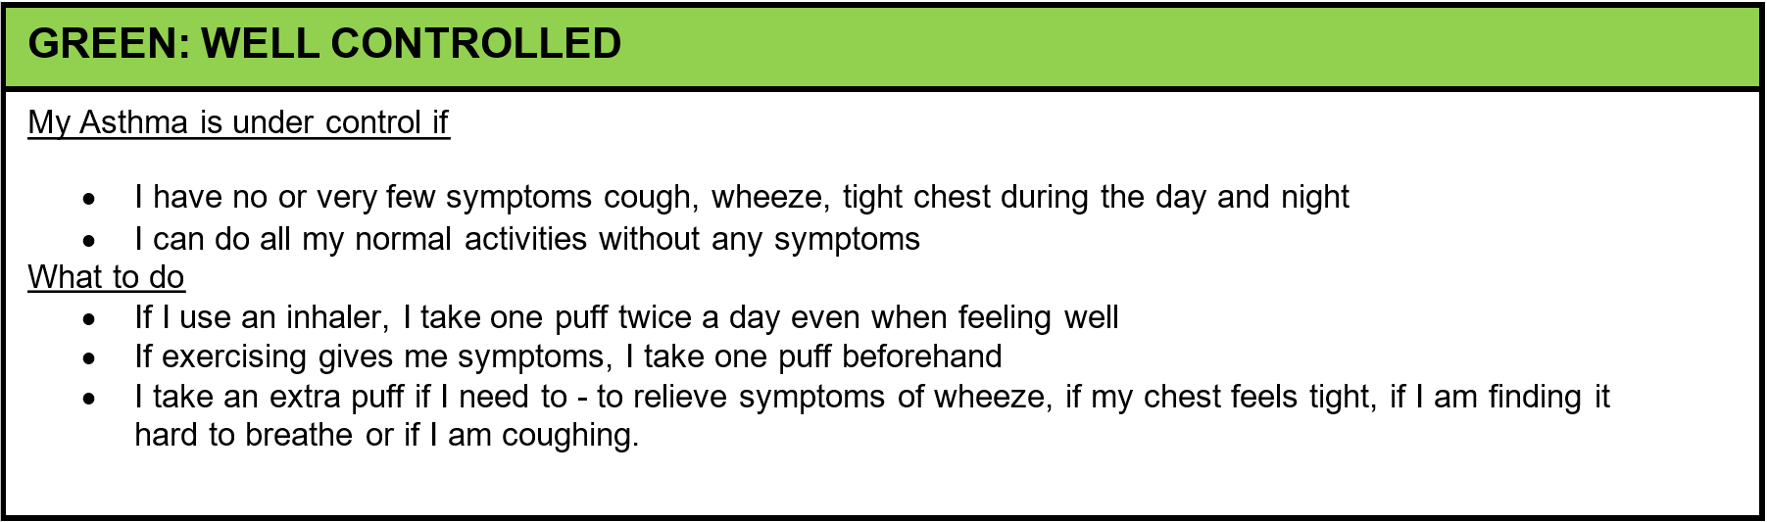
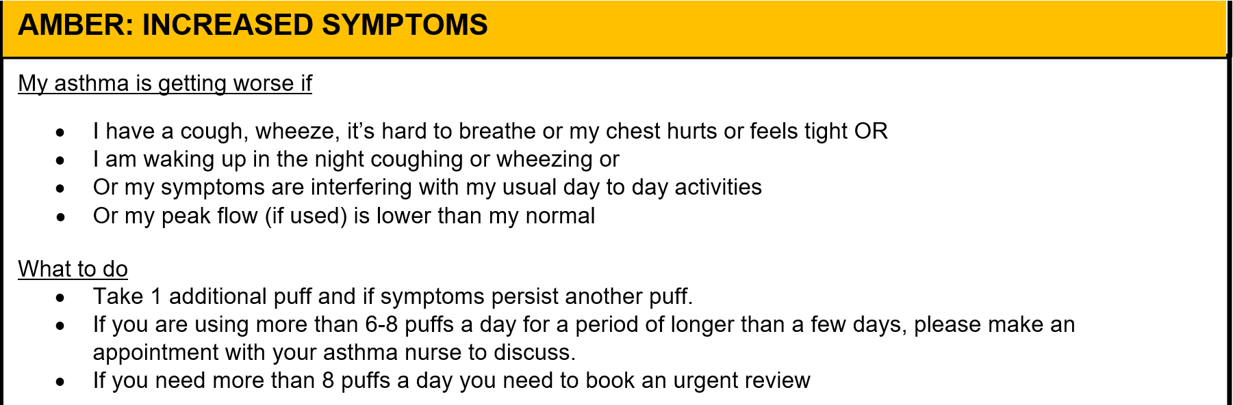
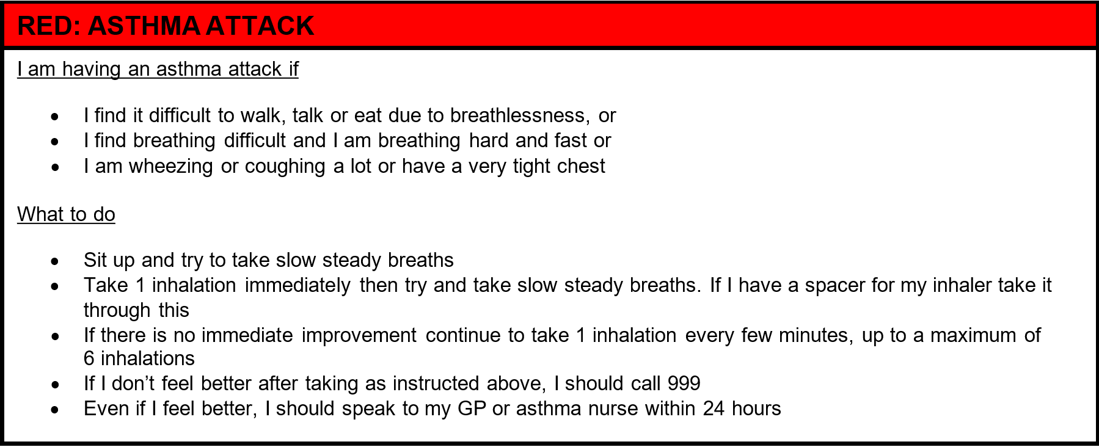
Inhalers: Fostair 100/6, Symbicort 100/6 and 200/6, Duoresp 160/4.5 and Fobumix 80/4.5 and 160/4.5 can be used with the MART asthma treatment regime.

