

**Menopause Symptom Questionnaire**

We would be grateful if you could complete and return this form before your consultation. It will help you and the clinician prepare, guide the clinician to the best HRT choices and allow more time for you in your appointment. After the questionnaire, please find a list of resources to help you prepare for your appointment. Thank you.

Sharon Hartmann RN, RSCN and DFSRH

|  |  |  |  |  |
| --- | --- | --- | --- | --- |
|  | **Not at all** | **A little** | **Quite a bit** | **A lot/very much** |
| **Heartbeat quickening, racing or palpitations** |  |  |  |  |
| **Trouble breathing** |  |  |  |  |
| **Feeling faint/ dizzy** |  |  |  |  |
| **Pressure or tightness in body** |  |  |  |  |
| **Pins and needles anywhere in your body** |  |  |  |  |
| **Tinnitus/ ear ringing** |  |  |  |  |
| **Joint/ muscle pains** |  |  |  |  |
| **Headaches** |  |  |  |  |
| **Hot flushes** |  |  |  |  |
| **Sweating at night** |  |  |  |  |
| **Difficulty sleeping** |  |  |  |  |
| **Feeling tired/ lacking energy /fatigue** |  |  |  |  |
| **Loss of interest /lack of motivation** |  |  |  |  |
| **Difficulty concentrating** |  |  |  |  |
| **Memory problems** |  |  |  |  |
| **Feeling nervous** |  |  |  |  |
| **Emotional** |  |  |  |  |
| **Anxiety/ panic attacks** |  |  |  |  |
| **Feeling low in mood, or depressed** |  |  |  |  |
| **Crying spells** |  |  |  |  |
| **Easily irritated** |  |  |  |  |
| **Reduced/ loss of sex drive** |  |  |  |  |
| **Vaginal dryness** |  |  |  |  |
| **Urinary symptoms** |  |  |  |  |

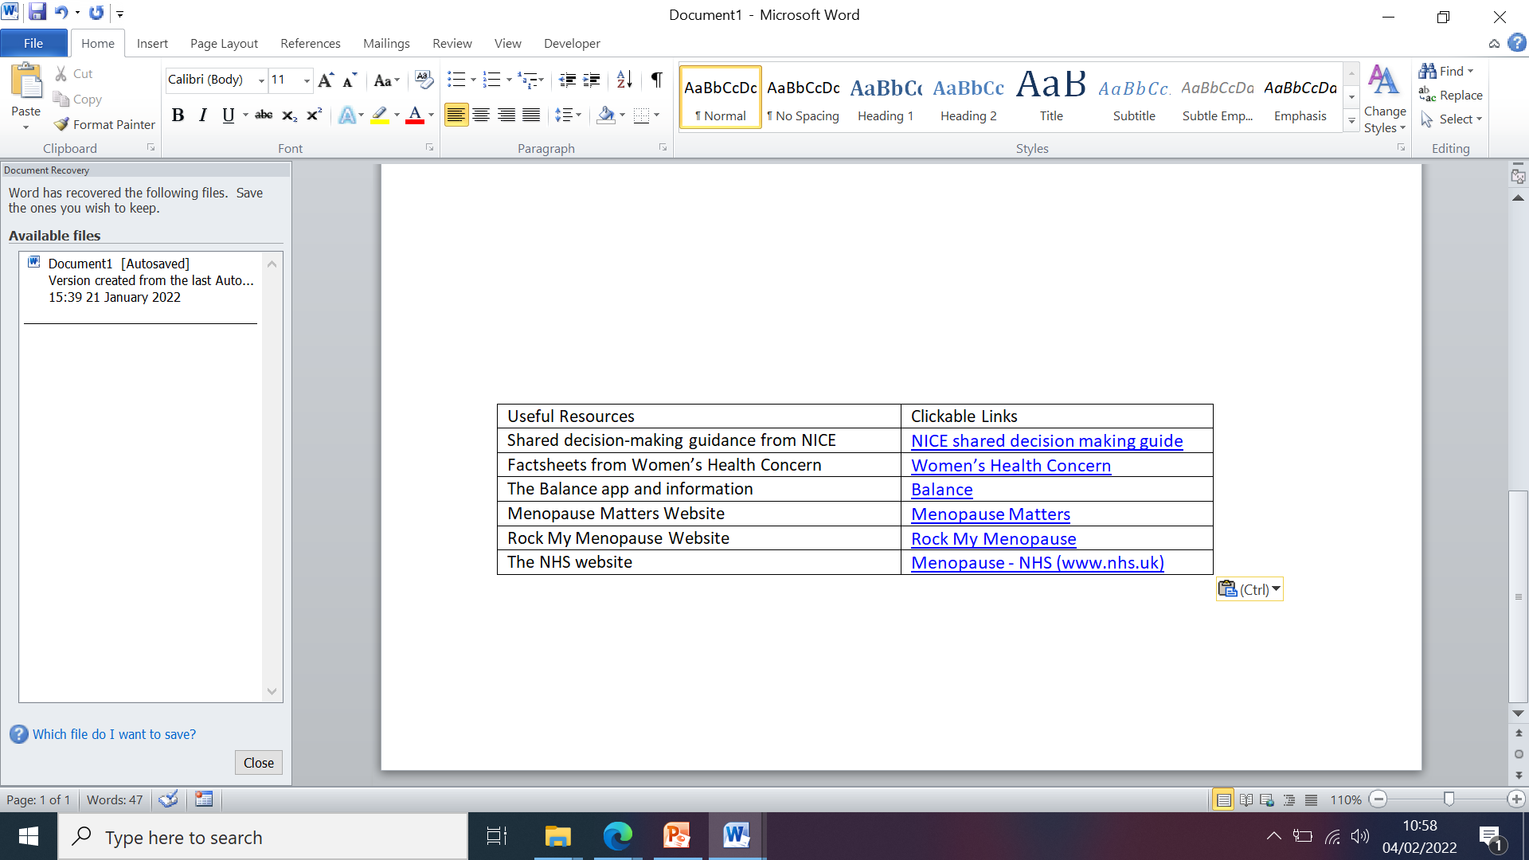****

Sharon Hartmann RN, RSCN and DFSRH

|  |  |
| --- | --- |
| **Medical History** | |
| Date of last menstrual period |  |
| Details of menstrual cycle (any changes, how often, how long for) |  |
| Have you ever had gynaecological surgery (including hysterectomy)? If “yes”, what surgery and when? |  |
| Are you currently using any form of contraception? If “yes”, what type? |  |
| If you have a Mirena coil, when was it inserted? |  |
| Are you currently on HRT? If so, what type? |  |
| Do you smoke/ have you ever smoked? If yes, how many a day, and how long for? |  |
| How much alcohol do you drink a week? |  |
| Please describe your current diet, and how active your lifestyle is |  |
| Have you ever had: a migraine, blood clot (e.g. deep vein thrombosis, pulmonary embolism, stroke), high blood pressure or heart problems? |  |
| Have any of your relatives had ovarian or breast cancer? If yes, how are you related to them, and how old were they when diagnosed? |  |
| Do you use any complementary therapies (e.g. St. John’s wort), or unprescribed medication/ drugs? |  |
| Do you currently take any vitamin D supplements? |  |
| Please state your current weight and height |  |
| What is your blood pressure (if able to take)? |  |